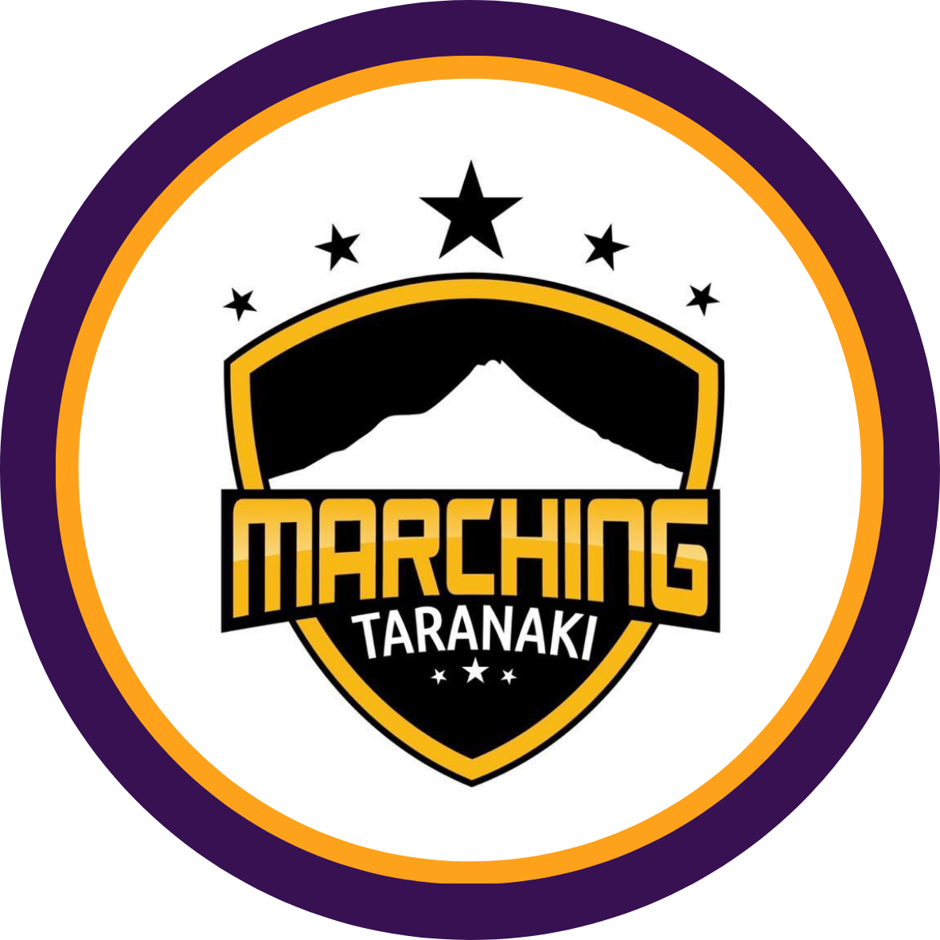
NORTH ISLAND CHAMPIONSHIPS
Taranaki 6th December 2025
TSB Hub, Hawera

UNDER 13 GRADE
🥇 1st Technical – Glennette - Wellington
Coaches Michelle & Aimee Burton
🥈2nd Technical – Silverdettes - Waikato
Coaches Lara Porter & Taylor Voeroes

🥇 1st Display – Glennette - Wellington
Coaches Michelle & Aimee Burton
🥈 2nd Display – Buckingham Guards – Hawke’s Bay
Coaches Stacey Sime & Calais Terry-Moore

🏆 CHAMPION U13 GRADE TEAM – Glennette - Wellington
Coaches Michelle & Aimee Burton

UNDER 18 GRADE
🥇 1st Technical – Buckingham Guards – Hawke’s Bay
Coaches Stacey Sime & Chelsea Cresswell
🥈 2nd Technical – Glennette - Wellington
Coach Cheryl Lovett
🥉 3rd Technical – Madison Blues - Waikato
Coaches Karen Bedingfield & Tamara Hayward

🥇 1st Display - Buckingham Guards – Hawke’s Bay
Coaches Stacey Sime & Chelsea Cresswell
🥈 2nd Display – Glennette - Wellington
Coach Cheryl Lovett
🥉 3rd Display – Madison Blues - Waikato
Coaches Karen Bedingfield & Tamara Hayward

🏆 CHAMPION U18 - GRADE TEAM – Buckingham Guards – Hawke’s Bay
Coaches Stacey Sime & Chelsea Cresswell

MASTERS GRADE
🥇 1st Technical – Bandolier - Wellington
Coach Wendy Lappin
🥇 1st Display – Bandolier - Wellington
Coach Wendy Lappin

🏆 CHAMPION MASTERS GRADE TEAM – Bandolier - Wellington
Coach Wendy Lappin

SENIOR GRADE
🥇 1st Technical – SWIS - Wellington
Coach Ema Wihapi-Solia

🥇 1st Display - SWIS - Wellington
Coach Ema Wihapi-Solia

🏆 CHAMPION SENIOR GRADE TEAM - SWIS - Wellington
Coach Ema Wihapi-Solia

