NZ Marching Championships 2022 - Souvenirs Order Form

Name / Team Name: ____________________________ Grade of Team: _____________________
Contact Number: ____________________________ Email: _________________________________
Please send completed order form to: marchingwaikatosouvenirs@gmail.com
Orders must be received by Marching Waikato by 4pm Friday, 25th February 2022. Orders will be available for pick at the venue from Thursday, 17th March 2022.
Alternatively, you can request your order be couriered. Courier charge will be advised when order is received. Please supply address in your email if you choose this option.

 | Item | Price | Quantity | Total
 | Waikato Badge | $12.00
 | NZ Champs Badge | $12.00
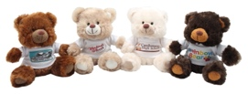 | Teddy Bear | $15.00
 | Bumper Stickers  “I Love Marching”  “Marching Girls Do It With Precision”  “Marching The Kiwi Way To Keep Fit” | $2.00  $2.00  $2.00  Or all 3 for $5.00
 | Drink Bottles 650ml | $20.00
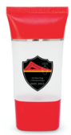 | Hand Sanitizer 30ml | $7.00
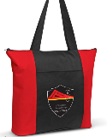 | Tote Bag | $15.00
 | Programme | $5.00

Payments are to be made to Marching Waikato 03-0314-0219849-00
Please put “Souvenirs” as the reference.

Remittance Slip
Name of Account Payment coming from: ___________________________________________________
Payment Total: ___________________ Payment Date: ___________________

